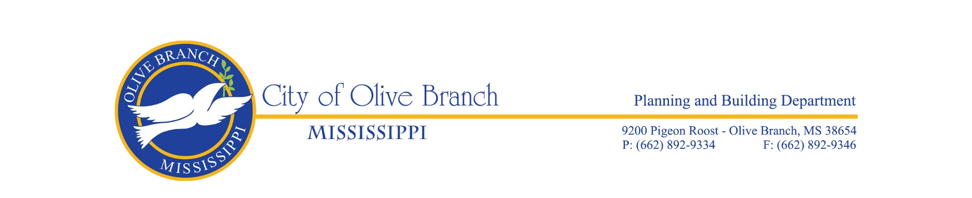

THE CITY OF OLIVE BRANCH DESIGN REVIEW ADVISORY COMMITTEE

AGENDA FOR THE REGULAR MEETING ON JANUARY 25, 2024

The Olive Branch Design Review Advisory Committee will hold its regular meeting on Thursday, January 25, 2024 in the Planning/Engineering Conference Room, City Hall, Room 143, located at 9200 Pigeon Roost Rd, Olive Branch, MS at 4:00pm.

CALL TO ORDER

ROLL CALL

APPROVAL OF THE MINUTES OF THE REGULAR MEETING OF OCTOBER 26, 2023

OLD BUSINESS

NEW BUSINESS

- Design Review Application for Scope Shop, 12,600+/- sq. ft. and 3,600 sq. ft. metal buildings on Lot 1 of the Scope Subdivision, Phase 1 submitted by Kyle Ham, Signal Source LLC, property owner. The subject property is zoned M-1, Light Industrial District and is located on the southwest side of HWY 178 north of the Old Craft Road intersection. (File #DR24-0001).

OTHER BUSINESS

ADJOURNMENT

